**CHAPTER 1**

**INTRODUCTION**

**1.1 Introduction**

As technology advances internet is becoming ever-popular. The website has become an essential part. Often website of awareness is used as a major requirement. Thus having a website is essential for any government organization. One the department of Health Ministry of India needs to have a useful and stunning website to spread awareness and use as a medium to interact with people, doctors, and the medical department. Notice, research works, reducing myths & facts, etc. can be the major advantages of a website.

Website development is a way to make people aware of the services you’re offering, and understand why your details or services are relevant and even necessary for them to learn and understand. Displaying this information with high-quality images and thought-out presentations will have a great influence on people, and it’s important to strive towards making your services as relatable and appealing as possible.

Additionally, with website development you can:

1. Communicate with people effectively
2. Improve your connectivity
3. Prove your reliability

Web development is usually divided into two major sections, namely: Front-end and Back-end. Front-end deals with what’s a user going to see whereas the back end deals with all the server-related stuff. In this project, we will develop a website for the Department of Health Ministry of India.

In this report, almost every detail that is necessary has been discussed. Although maximum effort has been given to make this awareness website. There are some optional features that can be included or excluded.

Also, the department has been very busy doing these tasks manually so a third party has been selected to host the website. It will cost something high a year. But the plus point is it will get 24/7 support. Cost can be minimized in this section, but maintenance has been given priority over cost.

A detailed task list and pictures have been included in this report to get a clear picture of this project. Every possible disclosure has been made to cover the maximum areas of the project. This report can be amended and changes can be made to the teachers.

The work will be done by me with a supervisor from faculty members. So no profit has been added. Only extra charges for different roles have been added. I do my best to interact with excellent database handling records.

A formal training phase is included in the project to train some departmental members on how to handle the website.

Overall a useful website can be really helpful for the department of Health Ministry of India.

**1.2 Aim and Objectives**

This awareness website works well for serving an informational purpose/thing but a necessary need is to generate leads or capture information, such as people’s details to do registration for the Covid-19 Vaccine, it is basically a non-profit website dedicated to raising awareness. The only reliable way to measure this goal is by surveying users before and after a redesign on how well they understand the new services.

The main objective behind this awareness website project is the following:

* Spread/ Increase Awareness
* Reduce Myths and facts which is forwarded through social media channels
* Easily registration of Covid-19 Vaccine through Website
* Display all the relevant data/ information which is related to Covid-19

**1.3 Motivation**

Web Development is the fastest-growing industry in the whole world. Being a web developer you face a lot of difficulties in your day-to-day life solving different problem statements for your clients or your job which you do as a web developer. Being focused and motivated becomes a difficult task many times as you get irritated by the daily tasks and work pressure. Today we will tell you some tips and tricks to stay motivated and passionate about your passion.

It is always best to learn about new technology and use it in your next project. We all know that we can build a responsive web application using HTML5, CSS, JavaScript, and Bootstrap. But this doesn’t mean that you cannot use any other libraries and frameworks for building responsive web applications. You can use other libraries of JavaScript like React, and Angular to build a progressive web application. By trying out a new technology you place yourself out of your comfort zone which helps you grow and succeed more in your life as a developer. But there is a disclaimer to this as well you need to not switch your technology all the time like taking a challenge to switch the technology after making quite a good amount of projects by yourself.

It is rightly said we learn from like people minded who have a greater experience than us. During these hard COVID-19 times, conferences are not taking place offline which is again a good part as travel expenses and food charges are saved, and now we should invest our time in applying for webinars and technology-related sessions which are taking place online through Zoom or any other video conferencing platforms.

As a developer, you should take small breaks and do outings with your family or close ones as it helps you to be close to nature and feel the fresh air which increases your productivity. Taking a Break isn’t bad until it is not too often. It should be better advised to take a break in a month for a single day.

The best part of open-source project development is that if you’re a key role player at the project you are building and you do the things very nicely then it builds online credibility for you.

**1.4 Scope**

No doubt, web development is a fantastic career option. One can be a front-end developer, a back-end developer, or even both. To start a career in the web world, one should have general programming skills. C#, NET, SharePoint, Web Services, PHP, Content Management system, Ruby on Rails, Cold Fusion, CSS, Java, Python, AJAX, ASP, J2EE /Java EE, DCOM/COM/Active X are included in this.

Many enterprises are today using web development and web structure for their companies; this includes

* Mobile App Development
* Digital Marketing
* Manufacturing Industry
* Banking Industry
* Software Industry
* Entertainment Industry
* Web Design Company

**CHAPTER 2**

**TECHNOLOGY DESCRIPTION**

**2.1 Introduction**

Our project is a website that gives you guidance on the day-to-day routine of the details of covid-19 and reduces myths which spread on daily news channels, Facebook, Twitter, Instagram, and other social media. To make this website I’ve used five technology/languages such that:

* HTML
* CSS
* Bootstrap
* JavaScript
* JSP (Java Server Pages)
* Java
* Tomcat 10.0
* MySQL

Our project is the go-to website for anyone who wants information related to corona and its updates. The home page is designed by simple HTML, CSS, Bootstrap, & JavaScript technology. Then the Vaccination form is designed in Html, CSS and JavaScript technology. Once it is done then MySQL database is connect it to save the details which the user entered.

Server: Apache Tomcat 10.0

Database: MySQL

Operating System: Windows 7/8/8.1/10

**2.2 Technical Details**

Front end is designed using HTML, CSS, and Bootstrap. JSP is used to perform behind the screen requests and JavaScript used to perform client side scripting. Backend is based on java + MySQL based Relational data base model. The SQL queries are run using the CI SQL library functions.

Backend online host includes a centralized database resident on the server, the script which is built in JSP used to SQL query the database on user’s request for transaction on data. The form are made using the HTML, Bootstrap for designing and Java, SQL for backend.

**2.3 Need of CMS**

If you have multiple admins for your website, implementing a CMS eases website editing for them. You can easily provide limited access to the administrators as per their requirement, and simultaneous update is made possible. The advantage of using a content management system is that you needn’t always depend on your web development company to make changes to your website. You can do it yourself with the help of a CMS.

You don’t need to know any programming language like HTML to build your website. Most content management software comes with a WYSIWYG editor. If you know how to create a simple word document, you can easily upload and maintain content on your website with the help of a CMS.

The changes can be made globally when using CMS. When you need to make a change in the website, be it the logo, a phone number or an image, it can be reflected across the whole website at one go rather than updating the changes page by page.

Using content management software can help you analyze the performance of your website.

**2.4 Technologies/ Languages**

**2.4.1 HTML**

HTML stands for Hyper Text Markup Language. It is used to design web pages using the markup language. HTML is the combination of Hypertext and Markup language. Hypertext defines the link between the web pages and markup language defines the text document within the tag that define the structure of web pages.[1]

HTML is used to create the structure of web pages that are displayed on the World Wide Web (www). It contains Tags and Attributes that are used to design the web pages. Also, we can link multiple pages using Hyperlinks.

The basic structure of an HTML page is laid out below. It contains the essential building-block elements (i.e. doctype declaration, HTML, head, title, and body elements) upon which all web pages are created.

* <DOCTYPE! html> – A doctype or document type declaration is an instruction that tells the web browser about the markup language in which the current page is written. It is not an element or tag. The doctype declaration is not case-sensitive.
* <html> – This tag is used to define the root element of HTML document. This tag tells the browser that it is an HTML document. It is the second outer container element that contains all other elements within it.
* <head> – This tag is used to define the head portion of the HTML document that contains information related to the document. Elements within the head tag are not visible on the front-end of a webpage.
* <body> – The body tag is used to enclose all the visible content of a webpage. In other words, the body content is what the browser will show on the front end.[1]

Example: This is the basic example of HTML that display the heading and paragraph content.

<!DOCTYPE html>

<html>

<!-- Head Section content -->

<head>

<!-- Page title -->

<title>Basic Web Page</title>

</head>

<!-- Body Section content -->

<body>

<!-- Used to display heading content -->

<h1>Welcome </h1>

<!-- Used to display paragrapg content -->

<p>A computer science portal</p>

</body>

</html>

**2.4.2 CSS**

CSS (Cascading Style Sheets)is used to apply styles to web pages. Cascading Style Sheets are fondly referred to as CSS. It is used to make web pages presentable. The reason for using this is to simplify the process of making web pages presentable. It allows you to apply styles on web pages. More importantly, it enables you to do this independently of the HTML that makes up each web page.

Styling is an essential property for any website. It increases the standards and overall look of the website that makes it easier for the user to interact with it. A website can be made without CSS, as styling is MUST since no user would want to interact with a dull and shabby website. So for knowing Web Development, learning CSS is mandatory.[2]

Basic Format: It is the basic structure of CSS style of an webpage.

body {

background-color: lightgray;

}

h1 {

color: green;

text-align: center;

}

p {

font-family: sans-serif;

font-size: 16px;

}

There are three types of CSS which are given below:

* Inline: Inline CSS contains the CSS property in the body section attached with the element known as inline CSS.
* Internal or Embedded: The CSS ruleset should be within the HTML file in the head section i.e the CSS is embedded within the HTML file.
* External: External CSS contains a separate CSS file that contains only style property with the help of tag attributes.

Why is CSS used in HTML?

* Solves a big problem: Font, color, background style, element alignments, border, and size tags had to be duplicated on each web page before CSS. This was a lengthy procedure.
* Saves a lot of time: Because CSS style definitions are stored in external CSS files, updating only one file can modify the entire website.
* Provide more attributes: CSS gives more specific features for defining the look and feel of a website than simple HTML.
* Pages load faster: CSS doesn’t require you to write HTML tag attributes all of the time. A tag’s rule can be written once and applied to all instances of the tag. As a result, CSS uses less code, resulting in speedier download times.
* Easier Website maintenance: CSS makes website maintenance much easier. If we need to make a global change to the file, we can simply alter the style, which will update all of the elements on the web page.
* Multiple device compatibility: We can use CSS with older language versions because it is compatible with them. CSS makes it possible to optimize material for several devices.
* Base for web development: HTML and CSS is the basic skill that every web developer should know. It is the basic skill that is required for building a website.
* Makes your website look attractive: A website that’s dull and plain will not attract the user, so adding some style would surely make your website presentable to the user.
* Makes the design come live: A web developer is responsible for making the design given to him as a live product. It is used for styling to develop the design of the website.
* Increases user experience of the website: A website with a simple yet beautiful UI would help the users to go through the website easily. It is used to make the user interface better.
* More career opportunities: Since CSS is a basic requirement while learning Web Development, therefor there are abundant career opportunities for it. As a freelancer, you can land up to many projects.[2]

Example: In this example, we will see how to apply styles using class and id.

<!DOCTYPE html>

<html lang="en">

<head>

<meta charset="UTF-8">

<meta http-equiv="X-UA-Compatible" content="IE=edge">

<meta name="viewport" content="width=device-width, initial-scale=1.0">

<title>CSS</title>

<!-- Stylesheet of web page -->

<style>

/* To color the background */

body {

background-color: rgb(221, 177, 136);

}

/* Text alignment Center */

.main {

text-align: center;

}

/* Text color, font size & font weight */

.GFG {

color: #009900;

font-size: 50px;

font-weight: bold;

}

/* Font Size and style */

#geeks {

font-style: bold;

font-size: 20px;

}

</style>

</head>

<body>

<div class="main">

<div class="GFG">GeeksforGeeks</div>

<div id="geeks">

A computer science portal for geeks

</div>

</div>

</body>

</html>

**2.4.3 JavaScript**

JavaScript (JS) is the world’s most popular lightweight, interpreted compiled programming language. It is also known as a scripting language for web pages. It can be used for Client-side as well as Server-side developments.[3]

JavaScript can be added to your HTML file in two ways:

* Internal JavaScript: We can add JS code directly to our HTML file by writing the code inside the <script> tag. The <script> tag can either be placed inside the <head> or the <body> tag according to the requirement.
* External JavaScript File: We can create a file with .js extension and paste the JS code inside it. After creating the file, add this file in <script src=”file_name.js”> tag inside <head> tag of the HTML file.

Syntax: It is the basic syntax to write code.

<script>

// JS Code

</script>

Example: It is the basic example to embed JS code in an HTML file.

<!DOCTYPE html>

<html lang="en">

<head>

<title>

Basic Example to Describe JavaScript

</title>

</head>

<body>

<!-- JavaScript code can be embedded inside

head section or body section -->

<script>

console.log("Welcome to GeeksforGeeks");

</script>

</body>

</html>

Why JavaScript is used?

* JavaScript is the most popular programming language for both client-side and server-side to make interactive web pages. It is mainly used to develop websites and web-based applications.
* Creating Interactive Websites: JavaScript is used to make the web pages dynamic and interactive. It means using JavaScript, we can change the web page content and styles dynamically.
* Building Applications: JavaScript is used to make web and mobile applications. To build the web and mobile apps, we can use most popular JavaScript frameworks like – ReactJS, React Native, Node.js etc.
* Web Servers: We can make robust server applications using JavaScript. To be precise we use JavaScript frameworks like Node.js and Express.js to build these servers.
* Game Development: JavaScript can be used to design Browser games. In JavaScript, lots of game engines available that provide frameworks for building games.

Why to learn JavaScript ?

* JavaScript is the most popular and hence the most loved language around the globe. Apart from this, there are abundant reasons to learn it. Below are a listing of few important points:
* No need of compilers: Since JavaScript is an interpreted language, therefore it does not need any compiler for compilations.
* Used both Client and Server-side: Earlier JavaScript was used to build client-side applications only, but with the evolution of its frameworks namely Node.js and Express.js, it is now widely used for building server-side applications too.
* Helps to build a complete solution: As we saw, JavaScript is widely used in both client and server-side applications, therefore it helps us to build an end-to-end solution to a given problem.
* Used everywhere: JavaScript is so loved because it can be used anywhere. It can be used to develop websites, games or mobile apps, etc.
* Huge community support: JavaScript has a huge community of users and mentors who love this language and take it’s legacy forward.[3]

**2.4.4 Bootstrap**

Bootstrap is a free and open-source tool collection for creating responsive websites and web applications. It is the most popular HTML, CSS, and JavaScript framework for developing responsive, mobile-first websites. Nowadays, the websites are perfect for all browsers (IE, Firefox, and Chrome) and for all sizes of screens (Desktop, Tablets, Phablets, and Phones). All thanks to Bootstrap developers – Mark Otto and Jacob Thornton of Twitter, though it was later declared to be an open-source project.[4][5]

By using this framework we can easily manipulate the styling of any web page, like font style, text color, background color, flex, grid system, etc. Bootstrap Version 4 & Version 5 are the most popular versions. There are lots of other CSS frameworks like Tailwind CSS, Bulma, and Foundation but among them, this framework is the most popular because of below mentioned features:

* It is Faster and Easier way for Web-Development.
* It creates Platform-independent web-pages.
* It creates Responsive Web-pages.
* It designs responsive web pages for mobile devices too.
* It is a free and open-source framework available on www.getbootstrap.com

**2.5 Server**

**2.5.1 Tomcat 10.0**

It is an open-source Java servlet container that implements many Java Enterprise Specs such as the Websites API, Java-Server Pages and last but not least, the Java Servlet. The complete name of Tomcat is "Apache Tomcat" it was developed in an open, participatory environment and released in 1998 for the very first time. It began as the reference implementation for the very first Java-Server Pages and the Java Servlet API. However, it no longer works as the reference implementation for both of these technologies, but it is considered as the first choice among the users even after that. It is still one of the most widely used java-sever due to several capabilities such as good extensibility, proven core engine, and well-test and durable. Here we used the term "servlet" many times, so what is java servlet; it is a kind of software that enables the webserver to handle the dynamic(java-based) content using the Http protocols.[6]

If you are a little familiar with the websites or have some basic knowledge about the websites, you must have heard about the HTTP protocol or may also know what actually are they. If you want to provide any web-services such as you want to provide a simple static content possibly by using HTML (or Hypertext Markup Language), or maybe you just want to send data from a server to point you, so you necessarily need a server and that server is HTTP(HyperText transfer protocol). So, as we all know that if anyone wants to make a simple, static website, he definitely requires an HTTP server, but if he wants to make website dynamic, he has to use servlet. We use the HTTP server if we want to send simple data. If we want to send dynamic data or to make our website dynamic, we need to use the servlet. Hence, we need an HTTP server and what else we need is a container where we will run or servlet, so when we combine the HTTP server and the servlet (or we can say servlet container), they both combine to become a single server know as tomcat server.[6]

* In simple words, we can say that The Apache Tomcat is actually a server and a servlet container.
* The Java ecosystem supports a wide variety of application servers, so let's have a little discussion on each of them and see where Tomcat fits in:

Play Videox.

* A servlet container is basically an implementation of the Java servlet specification, which is mainly used for the purpose of hosting Java servlets.
* The Java enterprise application-server is an implementation of the Java specification.
* A web- server is a kind of server designed to serve files using a local system such as Apache.
* We can say that, at the center, the Tomcat is JSP (Java Server Pages) and Servlet. The JSP is one of the server-side programming technologies that enables the developers to create platform-independent dynamic content and also known as the server-side view rendering technology. A servlet is a java-based software component that helps in extending the capabilities of a server. However, it can also respond to several kinds of requests and generally implemented web server containers to host the web-applications on the webservers. As the developer's point of view, we just have to write the java server pages (or JSP) or the servlet and not required to worry about routing; the Tomcat will handle the routing.
* The Tomcat also consists of the webserver known as the Coyote engine due to which it's possible to extend the capability of Tomcat to include several java enterprise specs, and including the Java Persistence API(JPA). The Tomcat also has an extended version known as the "TomEE" that contains more enterprise features.

Advantages of Tomcat:

Some significant advantages of Tomcat are as follows:

* It is open-source

It means anyone from anywhere can download, install, and use it free of cost, which makes it the first choice among the new developers and new users.

* Incredibly Lightweight

It is actually a very light application, even with the JavaEE's certification. However, it provides all necessary and standard functionalities required to operate a server, which means it gives very fast load and redeploys as compared to its various alternatives.

Yes, it is right that it does not offer so many features in case you want a number of features, it might be good for you, but if you want to have an easy and fast means in order to run your application, it is the best option for you.

* Highly flexible

Due to its built-in customization options, extensive and lightweight nature, it offers high flexibility, a user can run it in any fashion he wants, and it will still work as fine without any issues. Since it is open-source, anyone who has knowledge can tweak it according to his requirements.

* Stability

It is one of the most stable platforms available today to build on and using it to run our applications. It is incredibly stable because it runs independently of our Apache installation. In case if there is a big failure in Tomcat due to which it to stop working, the rest of our server would run just well.

* It provides us an extra level of security

As the several organizations usually like to position their Tomcat's installation behind the protection of an extra firewall which can be accessible only from the Apache installation.

* It is well documented

It has several excellent documentation available, including a vast range of freely available online tutorials that can be downloaded or viewed directly online by the user, which makes it one of the best choices to fill the requirement of an application server in mostly every java web-application. Whether a user is looking for the installation instructions, startup settings, server configuration notes, all kind of information about the Tomcat is already available on the internet.

* It is one of the most widely used application servers

According to an estimation, it holds almost 60 percent of the market share almost all java application server deployments, which makes it one of the most popular application servers used for java web-based applications. However, we cannot say that it implements all of the features required for a JavaEE application server; instead, it enables us to run Java EE application.

Tomcat acts as a "webserver" or "servlet container." However, there is a plethora of terminology for anything.

* It's mature

We take a look back in the past; we will find that it has existed for almost 20 years, which is quite a significant time, in which it gets mature over time passage. Since the Tomcat is open-source software, it's updated, and new releases come out nearly on a regular basis, and the open-source community maintains it. The maturity makes it one of the most extremely stable application servers for the development of software, applications, and deploying java applications. Since now, it is extremely a stable option that becomes more powerful with excellent community support.

Let discuss some disadvantages of Tomcat:

* It is not as fast as the Apache if we are working with the static pages
* It has some issues like a memory leak
* It's way to handle the logs.
* Issues in the SSL installations
* Its user interface is inferior and basic.

**2.6 Database**

**2.6.1 MySQL**

MySQL is a fast, easy-to-use RDBMS being used for many small and big businesses. MySQL is developed, marketed and supported by MySQL AB, which is a Swedish company.[7] MySQL is becoming so popular because of many good reasons −

* MySQL is released under an open-source license. So you have nothing to pay to use it.
* MySQL is a very powerful program in its own right. It handles a large subset of the functionality of the most expensive and powerful database packages.
* MySQL uses a standard form of the well-known SQL data language.
* MySQL works on many operating systems and with many languages including PHP, PERL, C, C++, JAVA, etc.
* MySQL works very quickly and works well even with large data sets.
* MySQL is very friendly to PHP, the most appreciated language for web development.
* MySQL supports large databases, up to 50 million rows or more in a table. The default file size limit for a table is 4GB, but you can increase this (if your operating system can handle it) to a theoretical limit of 8 million terabytes (TB).
* MySQL is customizable. The open-source GPL license allows programmers to modify the MySQL software to fit their own specific environments.

MySQL is currently the most popular database management system software used for managing the relational database. It is open-source database software, which is supported by Oracle Company. It is fast, scalable, and easy to use database management system in comparison with Microsoft SQL Server and Oracle Database. It is commonly used in conjunction with PHP.

MySQL follows the working of Client-Server Architecture. This model is designed for the end-users called clients to access the resources from a central computer known as a server using network services. Here, the clients make requests through a graphical user interface (GUI), and the server will give the desired output as soon as the instructions are matched. The process of MySQL environment is the same as the client-server model.[7]

The core of the MySQL database is the MySQL Server. This server is available as a separate program and responsible for handling all the database instructions, statements, or commands. The working of MySQL database with MySQL Server are as follows:

1. MySQL creates a database that allows you to build many tables to store and manipulate data and defining the relationship between each table.
2. Clients make requests through the GUI screen or command prompt by using specific SQL expressions on MySQL.
3. Finally, the server application will respond with the requested expressions and produce the desired result on the client-side.

**CHAPTER 3**

**DATA FLOW DIAGRAM**

Data Flow Diagrams show the flow of data from external entities into the system, and from one process to another within the system.[8] There are four symbols for drawing a DFD:

1. Rectangles representing external entities, which are sources or destinations of data.
2. Eclipse representing processes, which take data as input, validate and process it and output it.
3. Arrows representing the data flows, which can either be electronic data or physical items.
4. Open-ended rectangles or a Disk symbol representing data stores, including electronic stores such as databases or XML files and physical stores such as filling cabinets or stacks of paper.

Figures below are the Data Flow Diagrams for the current system. Each process within the system is first shown as a Context Level DFD and later as a Detailed DFD. The Context Level DFD provides a conceptual view of the process and its surrounding input, output and data stores. The Detailed DFD provides a more detailed and comprehensive view of the interaction among the sub-processes within the system.[8]

**3.1 Zero Level DFD Diagram:**

It is also known as a context diagram. It’s designed to be an abstraction view, showing the system as a single process with its relationship to external entities. It represents the entire system as a single bubble with input and output data indicated by incoming/outgoing arrows.

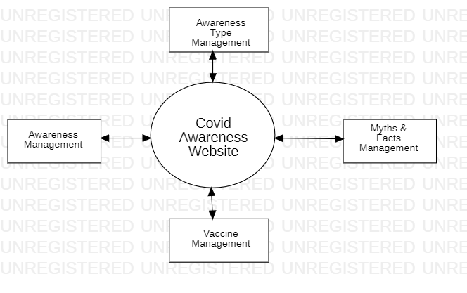

Fig 3.1 Zero Level DFD Diagram

**3.2 First Level DFD Diagram**

In 1-level DFD, the context diagram is decomposed into multiple bubbles/processes. In this level, we highlight the main functions of the system and breakdown the high-level process of 0-level DFD into sub processes.

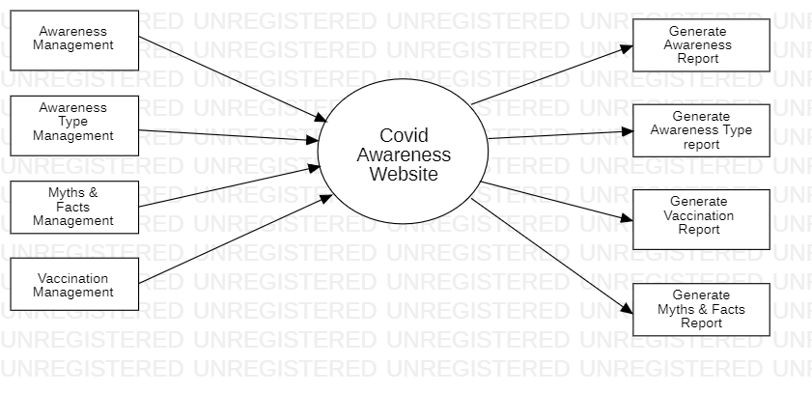

Fig 3.2 First Level DFD Diagram

**3.3 Second Level DFD Diagram**

In 2-level DFD goes one step deeper into parts of 1-level DFD. It can be used to plan or record the specific/necessary detail about the system’s functioning.

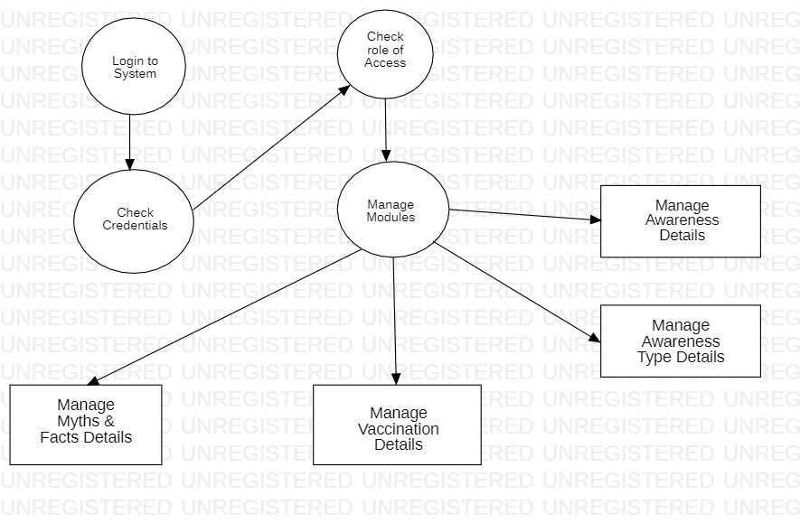

Fig 3.3 Second Level DFD Diagram

**CHAPTER 4**

**SOURCE CODE**

**4.1 Home Page Code:**

<!DOCTYPE html>

<html>

<head>

<title>Covid Awareness Website</title>

<link rel="stylesheet" type="text/css" href="css/main.css">

<link rel="stylesheet" type="text/css" href="css/bootstrap.min.css">

</head>

<body>

<nav>

<li><aclass="active" href="index.html">Covid Awareness</a></li>

<li><a href="#symptoms">Symptoms</a></li>

<li><a href="#impinfo">Important Info</a></li>

<li><a href="#precautions">Precautions</a></li>

<li><a href="page2.html#quicklinks">Quick Links</a></li>

<li><a href="page2.html#mythbusters">Myths vs Facts</a></li>

<li><a href="form.html">Vaccination Form</a></li>

</nav>

<div class="content">

<div class="image1">

<img src="img/MainImage.jpg">

</div>

<div class="Gif">

<div class="Gif1">

<img src="img/gif/Gif1.gif" style="width:100%">

</div>

<div class="Gif2">

<img src="img/gif/Gif2.gif" style="width:100%">

</div>

</div>

<hr><br>

<center><h1 id="hashtag1">#IndiaWillDefeatCorona</h1></center>

<center><p id="symptoms">Government of India is taking all necessary steps to ensure that we are prepared well to face the challenge and threat posed by the growing pandemic of COVID 19 – the Corona Virus. With active support of the people of India, we have been able to contain the spread of the Virus in our country. The most important factor in preventing the spread of the Virus locally is to empower the citizens with the right information and taking precautions as per the advisories being issued by Ministry of Health & Family Welfare.</p></center>

<div>

<center><img src="img/symptoms.jpg"></center>

</div>

<div class="CauseSolution">

<div class="Causes">

<img src="img/block-one.jpg" style="width:100%">

</div>

<div class="Causes">

<img src="img/block-two.jpg" style="width:100%">

</div>

</div>

<hr>

<div class="imp-info-area" id="impinfo">

<h3 class="important-heading">

<strong>Important Information For Corona - Virus</strong>

</h3>

<div class="block">

<div class="icon">

<img src="img/impinfo/icon-one.png" alt="" />

</div>

<div class="text-area">

<h3><strong>+91-11-23978046 or 1075</strong></h3>

<p>Dial National Helpline Number</p>

</div>

</div>

<div class="block">

<div class="icon">

<a href="https://www.mohfw.gov.in/pdf/coronvavirushelplinenumber.pdf" target="_blank">

<img src="img/impinfo/icon-two.png" alt="" />

</a>

</div>

<div class="text-area">

<a href="https://www.mohfw.gov.in/pdf/coronvavirushelplinenumber.pdf" target="_blank">

<h3><strong>States &amp; Union Territories</strong></h3>

<p></p></a>

<p><a href="https://www.mohfw.gov.in/pdf/coronvavirushelplinenumber.pdf" target="_blank">View pdf for Helpline Number</a></p>

</div>

</div>

<div class="block">

<div class="icon">

<a href="mailto:ncov2019@gov.in">

<img src="img/impinfo/icon-three.png" alt="" />

</a>

</div>

<div class="text-area">

<a href="mailto:ncov2019@gov.in">

<h3><strong>ncov2019@gov.in</strong></h3>

<p>Helpline Email ID </p>

</a>

</div>

</div>

<div class="block">

<div class="icon">

<a href="https://www.mohfw.gov.in/pdf/SOPforqurantine.pdf" target="_blank">

<img src="img/impinfo/icon-four.png" alt="" />

</a>

</div>

<div class="text-area">

<a href="https://www.mohfw.gov.in/pdf/SOPforqurantine.pdf" target="_blank">

<h3><strong>States/UTs for quarantine</strong></h3>

</a>

<a href="https://www.mohfw.gov.in/pdf/SOPforqurantine.pdf" target="_blank">

<p>Guidelines</p>

</a>

</div>

</div>

</div>

<br><hr><br>

<section class="followSteps" id="precautions">

<div class="stepHeading">

<div class="container text-center">

<h2>Follow these simple and easy Precautionary measures, and help yourself & those around you stay unaffected and healthy. </h2>

</div>

</div>

<div class="steps-covid">

<div class="container-fluid">

<div class="row">

<div class="col-xs-4">

<div class="covidThumb">

<img src="img/icons/icon-1.png" alt="icon">

<span>Wash your Hands <br>Frequently </span>

</div>

</div>

<div class="col-xs-4">

<div class="covidThumb">

<img src="img/icons/icon-2.png" alt="icon">

<span>Maintain Social <br>Distancing </span>

</div>

</div>

<div class="col-xs-4">

<div class="covidThumb">

<img src="img/icons/icon-3.png" alt="icon">

<span>Practice Respiratory <br>Hygiene </span>

</div>

</div>

</div>

<div class="row">

<div class="col-xs-4">

<div class="covidThumb">

<img src="img/icons/icon-4.png" alt="icon">

<span>Avoid touching Eyes, <br>Nose & Mouth </span>

</div>

</div>

<div class="col-xs-4">

<div class="covidThumb">

<img src="img/icons/icon-5.png" alt="icon">

<span>Stay informed </span>

</div>

</div>

<div class="col-xs-4">

<div class="covidThumb">

<img src="img/icons/icon-6.png" alt="icon">

<span>Heed to Precautionary <br>Measures </span>

</div>

</div>

</div>

</div>

</div>

</section>

<hr>

<div class="social-hub" id="socialhub">

<h3 class="important-heading">

<strong>MYGOV Social Hub</strong>

</h3>

<div class="block whatsapp">

<div class="icon">

<a href="https://wa.me/919013353535?text=Hi" target="_blank">

<img src="img/icons/whatsapp.png" alt="" />

</a>

</div>

<div class="text-area">

<a href="https://wa.me/919013353535?text=Hi" target="_blank">

<h3><strong>+91-9013353535</strong></h3></a>

<p><a href="https://wa.me/919013353535?text=Hi" target="_blank">WhatsApp</a></p>

</div>

</div>

<div class="block telegram">

<div class="icon">

<a href="https://t.me/MyGovCoronaNewsdesk" target="_blank">

<img src="img/icons/telegram.png" alt="" />

</a>

</div>

<div class="text-area">

<a href="https://t.me/MyGovCoronaNewsdesk" target="_blank">

<h3><strong>MyGovCorona</strong></h3>

<p></p></a>

<p><a href="https://t.me/MyGovCoronaNewsdesk" target="_blank">Telegram</a></p>

</div>

</div>

<div class="block messenger">

<div class="icon">

<a href="https://www.messenger.com/t/MyGovIndia" target="_blank">

<img src="img/icons/messenger.png" alt="" />

</a>

</div>

<div class="text-area">

<a href="https://www.messenger.com/t/MyGovIndia" target="_blank">

<h3><strong>MyGovIndia</strong></h3>

<p></p></a>

<p><a href="https://www.messenger.com/t/MyGovIndia" target="_blank">Facebook Messenger</a></p>

</div>

</div>

<div class="block facebook">

<div class="icon">

<a href="https://www.facebook.com/MyGovIndia/" target="_blank">

<img src="img/icons/facebook.png" alt="" />

</a>

</div>

<div class="text-area">

<a href="https://www.facebook.com/MyGovIndia/" target="_blank">

<h3><strong>@MyGovIndia</strong></h3>

<p></p></a>

<p><a href="https://www.facebook.com/MyGovIndia/" target="_blank">Facebook Page</a></p>

</div>

</div>

</div>

<hr>

</div>

<footer>

<p>Designed by: <a target="_blank"> SHUBHAM SHARMA (1900820100145)</a>

</footer>

</body>

</html>

**4.2 Second Page Code:**

<!DOCTYPE html>

<html>

<head>

<title>Covid Awareness Website</title>

<link rel="stylesheet" type="text/css" href="css/page2.css">

<link rel="stylesheet" type="text/css" href="css/main.css">

</head>

<body>

<nav>

<li><a class="active" href="index.html">Covid Awareness</a></li>

<li><a href="index.html#symptoms">Symptoms</a></li>

<li><a href="index.html#impinfo">Important Info</a></li>

<li><a href="index.html#precautions">Precautions</a></li>

<li><a href="#quicklinks">Quick Links</a></li>

<li><a href="#mythbusters">Myths vs Facts</a></li>

<li><a href="form.html">Vaccination Form</a></li>

</nav>

<div class="content">

<div class="quicklinks" id="quicklinks">

<h1 align="center">Quick Links</h1>

<div class="container">

<div class="infoboxes">

<ahref="https://static.mygov.in/rest/s3fs-public/mygov_159098900251307401.pdf" title="Click to view details" target="_blank">

<img src="img/quicklinks/mha5.jpg" />

</a>

<a href="https://www.pmcares.gov.in/en/" title="Click to view details" target="_blank">

<img src="img/quicklinks/pmcare_donate.jpg" />

</a>

<ahref="https://static.mygov.in/rest/s3fs-public/mygov_159015121455063671.pdf" title="Click to view details" target="_blank">

<img src="img/quicklinks/air-passenger.jpg" />

</a>

<a href="https://transformingindia.mygov.in/aatmanirbharbharat/" title="Click to view details" target="_blank">

<img src="img/quicklinks/aatmanirbhar.jpg" />

</a>

<a href="https://transformingindia.mygov.in/covid-19" title="Click to view details" target="_blank">

<img src="img/quicklinks/transformingindia.jpg" />

</a>

<a href="https://static.mygov.in/rest/s3fs-public/mygov_159107209055063671.pdf" title="Click to view details" target="_blank">

<img src="img/quicklinks/unlock1.jpg" />

</a>

</div>

</div>

</div>

<hr>

<div class="overview">

<h2 style="text-align: center;"> Coronavirus Disease: Overview </h2>

<div class="Gif3">

<img src="img/gif/Gif3.gif" style="width:100%">

</div>

<center><p> Coronavirus disease (COVID-19) is a communicable disease instigated by a newly discovered virus called coronavirus. The majority of the people infected with coronavirus usually experience mild or moderate respiratory illness. Mostly, they recover without undergoing any special treatment. However, older people and those suffering from an underlying medical problem such as cardiovascular disease, chronic respiratory disease, diabetes, and cancer are more susceptible to developing a serious illness. The best way of preventing and slowing down the transmission of this disease is by being well-informed about the virus, its progression and its transmission. You can protect yourself against this disease by frequently washing and sanitising your hands. It is also recommended to avoid touching your face. </p>

<p> The COVID-19 virus primarily spreads through discharge from the nose or droplets of saliva when an infected person sneezes or coughs. So, it’s also very important to practice respiratory etiquette, for instance, coughing into a flexed elbow. At present, there are no specific treatments or vaccines for COVID-19. However, a number of ongoing clinical trials are evaluating potential treatments.</p></center>

</div>

<br><hr>

<center>

<p id="activities"><b>Activities</b></p>

</center>

<div>

<div class="Activity">

<a href="https://www.mygov.in/group-issue/share-your-ideas-suggestions-help-fight-coronavirus/?utm_source=webcampaign&group_issue&285571">

<img src="img/Activity1.jpg" style="width:100%">

</a>

</div>

<div class="Activity">

<a href="https://quiz.mygov.in/quiz/the-ayush-sanjivani-quiz/">

<img src="img/Activity2.jpg" style="width:100%">

</a>

</div>

<div class="Activity">

<a href="https://self4society.mygov.in/">

<img src="img/Activity3.jpg" style="width:100%">

</a>

</div>

<div class="Activity">

<a href="https://pledge.mygov.in/vocalaboutlocal/">

<img src="img/Activity4.jpg" style="width:100%">

</a>

</div>

</div>

<br><hr color="white">

<hr>

<center><p id="mythbusters"><b>MYTH BUSTER</b></p></center>

<div class="myths">

<div class="row">

<div class="Myth">

<img src="img/myths/Myth-16.jpg" style="width:100%">

</div>

<div class="Myth">

<img src="img/myths/Myth-15.jpg" style="width:100%">

</div>

<div class="Myth">

<img src="img/myths/Myth-14.jpg" style="width:100%">

</div>

</div>

<br>

<div class="row">

<div class="Myth">

<img src="img/myths/Myth-13.jpg" style="width:100%">

</div>

<div class="Myth">

<img src="img/myths/Myth-12.jpg" style="width:100%">

</div>

<div class="Myth">

<img src="img/myths/Myth-11.jpg" style="width:100%">

</div>

</div>

<br>

<div class="row">

<div class="Myth">

<img src="img/myths/Myth-10.jpg" style="width:100%">

</div>

<div class="Myth">

<img src="img/myths/Myth-9.jpg" style="width:100%">

</div>

<div class="Myth">

<img src="img/myths/Myth-8.jpg" style="width:100%">

</div>

</div>

<br>

</div>

</div><br>

<footer>

<p>Designed by: <a target="_blank"> SHUBHAM SHARMA (1900820100145)</a>

</footer>

</body>

</html>

**CHAPTER 5**

**OUTPUT SCREEN**

**5.1 Website Homepage**

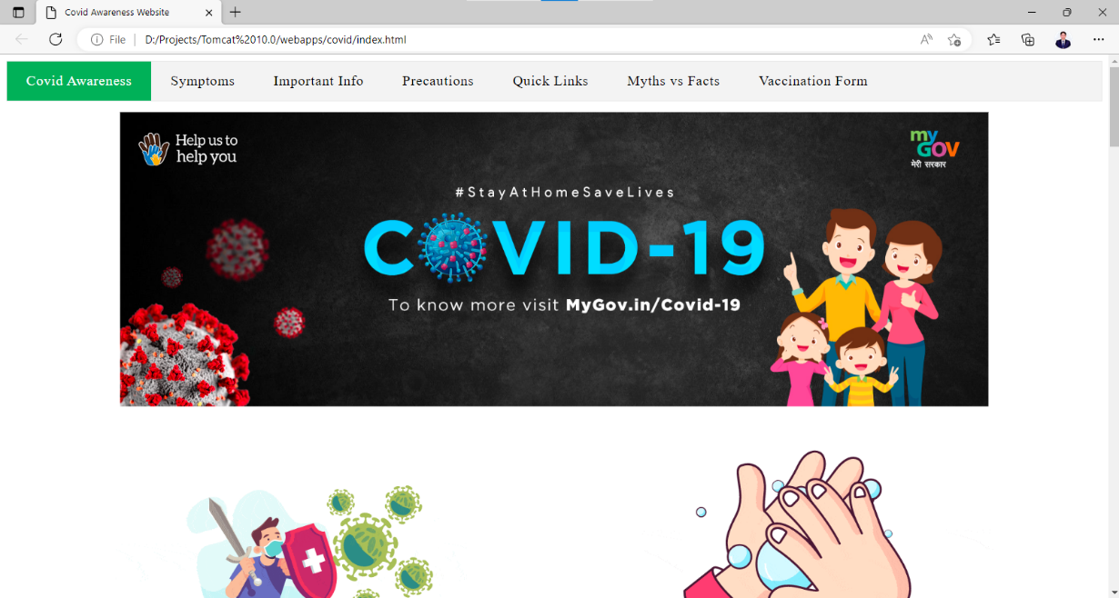

Fig 5.1 Website Homepage Front

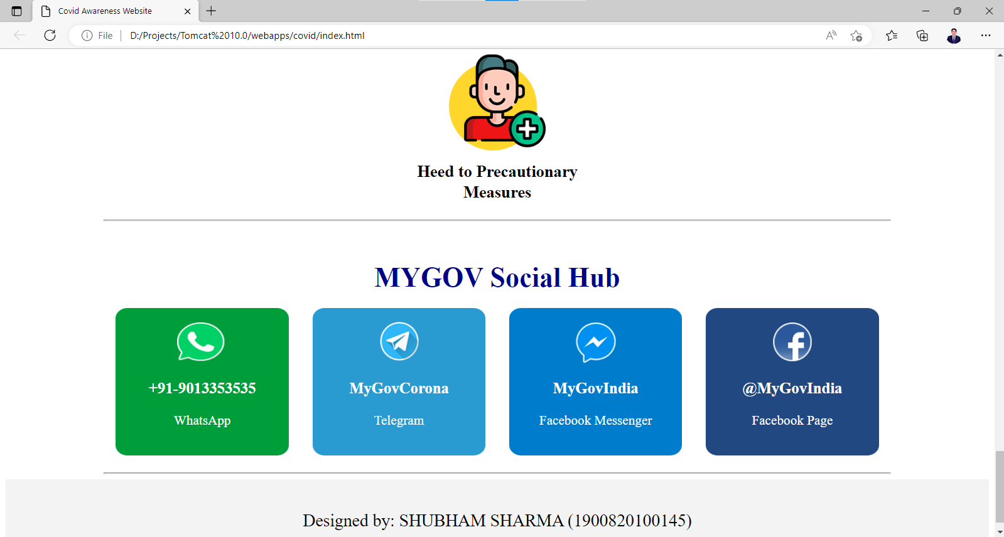

Fig 5.2 Website Homepage Middle

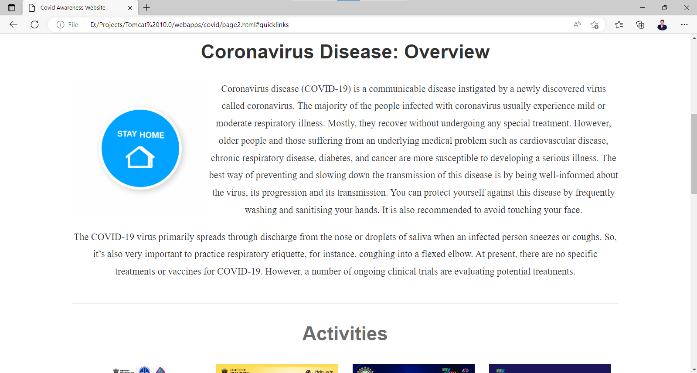

Fig 5.3 Website Homepage End

**5.2 Website Form**

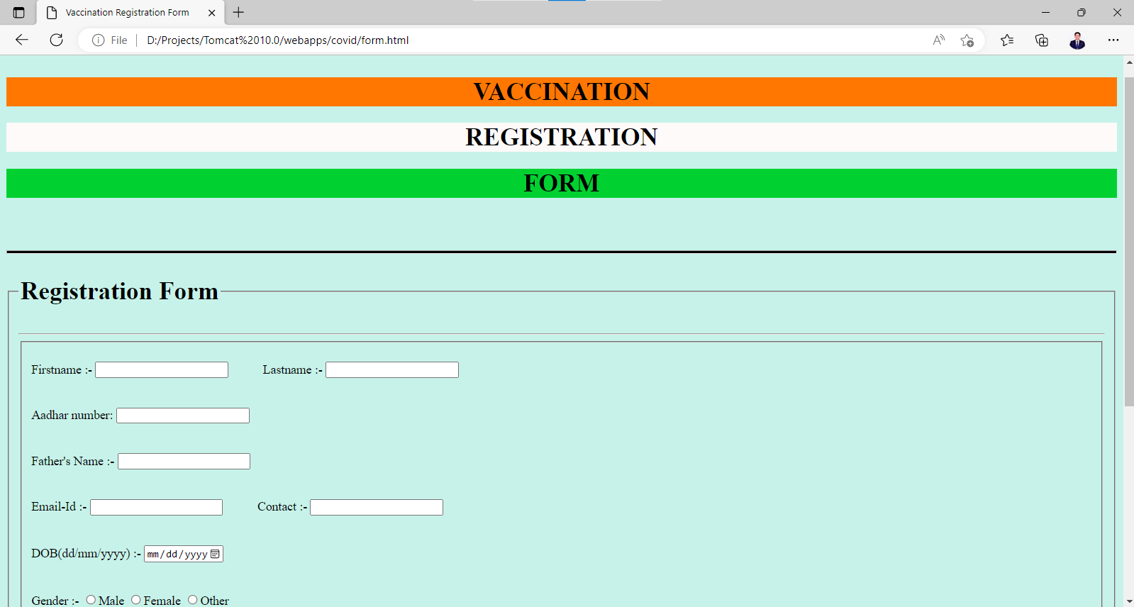

Fig 5.4 Website Form

**CHAPTER 6**

**CONCLUSION**

This awareness website works well for serving an informational purpose/thing but a necessary need is to generate leads or capture information, such as people’s details to do registration for the Covid-19 Vaccine, it is basically a non-profit website dedicated to raising awareness. The only reliable way to measure this goal is by surveying users before and after a redesign on how well they understand the new services.

The main objective behind this awareness website project is the following:

* Spread/ Increase Awareness
* Reduce Myths and facts which is forwarded through social media channels
* Easily registration of Covid-19 Vaccine through Website
* Display all the relevant data/ information which is related to Covid-19

We have successfully implemented the site “Covid Awareness Website”. With the help of various links and tools, we have been able to provide a site which will be live soon and running on web.

We have been successfully in our attempt to take care of the needs of both the users as well as the administrator. Finally we hope that this will go a long way in popularizing.

**CHAPTER 7**

**FUTURE SCOPE**

The work covered in the thesis tries to solve various issues, which emerged as a result of literature survey. Still there are many unopened questions left and are of interest were identiﬁed and are mentioned below:

* **Web Security At Client Side**

In this research work we proposed PECA, but it still has shortcomings. For example, when web document is required to be save in the portable extended memory it reduces the security due to decentralization of data. During update sat client side malicious codes may transfer to the client machine. So, a web security framework is required at the client side to make PECA more secure and better performer. So in near future, PECA and SWAM may be merged.

* **Server Side Load Balancing**

Load balancing is a concept which is still under research. Everyday new frame-works, algorithms and models are being developed and existing models are up-dated. There is a vast scope for future enhancement. For example, the users are sending arbitrary data as a query on the web, and hence web-centric queries can be optimized at server level to reduce server load to improve the server performance.

* **Ant Based Technology for Collective Intelligence At Server Side**

The developers are distributing server’s data to reduce the server’s load. This mechanism is increasing the requirement of collective intelligence. In this research work, ant technology for collective intelligence is used, but this is framework is based on client’s query.

**REFERENCES**

[1] W3schools.com. (2022). HTML Elements and Attributes [online] Available at: https://www.w3schools.com/html/ [Accessed 18 Sep.2022].

[2] Geeksforgeeks.org. (2022). Cascading Style Sheets and Example. [online] Available at: https://www.geeksforgeeks.org/css-introduction/ [Accessed 17 Oct.2022].

[3] Javatpoint. (2022). JavaScript and Examples. [online] Available at: https://www.javatpoint.com/javascript-tutorial [Accessed 17 Oct. 2022].

[4] Getbootstrap.com. (2022). Grid Template for Bootstrap. [online] Available at: https://getbootstrap.com/examples/grid/ [Accessed 17 Oct. 2022].

[5] Tutorialrepublic.com. (2022). Understanding the Bootstrap 3 Grid System - TutorialRepublic. [online] Available at: http://www.tutorialrepublic.com/twitter-bootstrap-tutorial/bootstrap-grid-system.php [Accessed 18 Oct. 2022].

[6] Apachetomcat.org. (2022). Tomcat Server documentation and problems. [online] Available at: https://tomcat.apache.org/ [Accessed 18 Oct. 2022].

[7] Mysql.com. (2022). MySQL and its all things. [online] Available at: https://www.mysql.com/ [Accessed 18 Oct. 2022].

[8] Geeksforgeeks.com. (2022). Data Flow Diagrams . [online] Available at: https://www.geeksforgeeks.org/what-is-dfddata-flow-diagram/ [Accessed 18 Oct. 2022].